Missing Data Analysis Report
Sri Lanka Civil Registration and Vital Statistics (CRVS)
Birth Registration Study — Parity and Its Determinants

Generated: 28 April 2026, 13:07
Methodology reference: Section 3.4.2 (Rubin, 1976; Little & Rubin, 2002)

1. Executive Summary
The raw CRVS dataset contained 301,712 birth records across 0 analytical variables. After applying listwise deletion to the regression-relevant variable set, 274,009 records were retained and 27,703 were dropped (9.18% of the original sample).

2. Methodological Framework
Missing data are classified per Rubin's (1976) typology into three mechanisms: Missing Completely At Random (MCAR), Missing At Random (MAR), and Missing Not At Random (MNAR). The methodology adopted listwise deletion as the primary approach, justified by the very large sample size of the CRVS dataset and the relatively low expected missingness rate for most variables. This approach is consistent with practice in large-scale demographic studies (Rutstein & Rojas, 2006; Sterne et al., 2009).

2.1 Missingness Severity Bands
Following Sterne et al. (2009), missingness was classified as:
- Low: < 5% — listwise deletion safe.
- Moderate: 5–15% — examine pattern.
- High: 15–30% — careful examination required.
- Very high: > 30% — sensitivity analysis required.

3. Univariate Missingness (Section 3.4.2.1)
Table 1 reports the count and percentage of missing values for every analytical variable in the raw dataset, classified by severity band.
Table 1. Univariate missingness by variable.
Variable | N missing | N present | Missing (%) | Severity
Birth_Weight(grams) | 33,542 | 268,170 | 11.12% | Moderate (5–15%) — examine pattern
Birth_Order2.0 | 27,218 | 274,494 | 9.02% | Moderate (5–15%) — examine pattern
Birth_Order | 27,218 | 274,494 | 9.02% | Moderate (5–15%) — examine pattern
Race_of_Father | 1,231 | 300,481 | 0.41% | Low (< 5%) — listwise deletion safe
Race_of_Mother | 520 | 301,192 | 0.17% | Low (< 5%) — listwise deletion safe
Age of Mother | 154 | 301,558 | 0.05% | Low (< 5%) — listwise deletion safe
Marital_Status | 17 | 301,695 | 0.01% | Low (< 5%) — listwise deletion safe
Gender | 2 | 301,710 | 0.00% | Low (< 5%) — listwise deletion safe
Registered_Month | 0 | 301,712 | 0.00% | Complete (0%)
Registered_Year | 0 | 301,712 | 0.00% | Complete (0%)
Multiple_Birth_Status | 0 | 301,712 | 0.00% | Complete (0%)
Hospital or Not | 0 | 301,712 | 0.00% | Complete (0%)
Birth_Month | 0 | 301,712 | 0.00% | Complete (0%)
Birth_Month.0 | 0 | 301,712 | 0.00% | Complete (0%)
Birh_Year | 0 | 301,712 | 0.00% | Complete (0%)
Birh_Year 2.0 | 0 | 301,712 | 0.00% | Complete (0%)
Registered_District | 0 | 301,712 | 0.00% | Complete (0%)
District_of_Mother | 0 | 301,712 | 0.00% | Complete (0%)

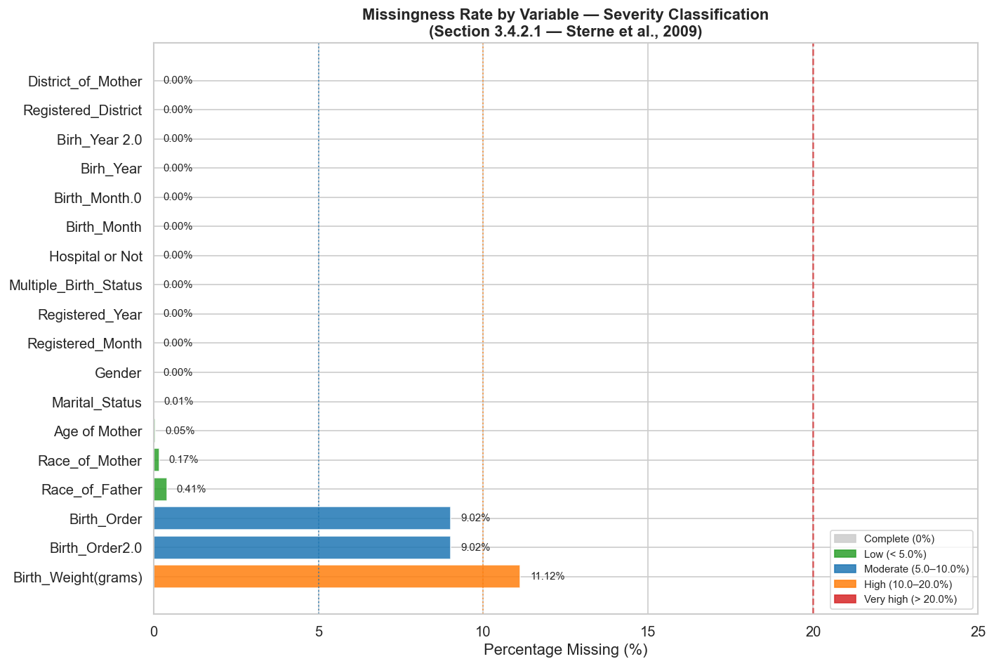
Figure 1. Missingness rate by variable, with severity-band thresholds.

4. Missingness Patterns (Section 3.4.2.2)
The pattern of missingness across variables was examined to detect whether records tend to be missing on multiple variables simultaneously (block missingness) or whether missingness occurs independently.
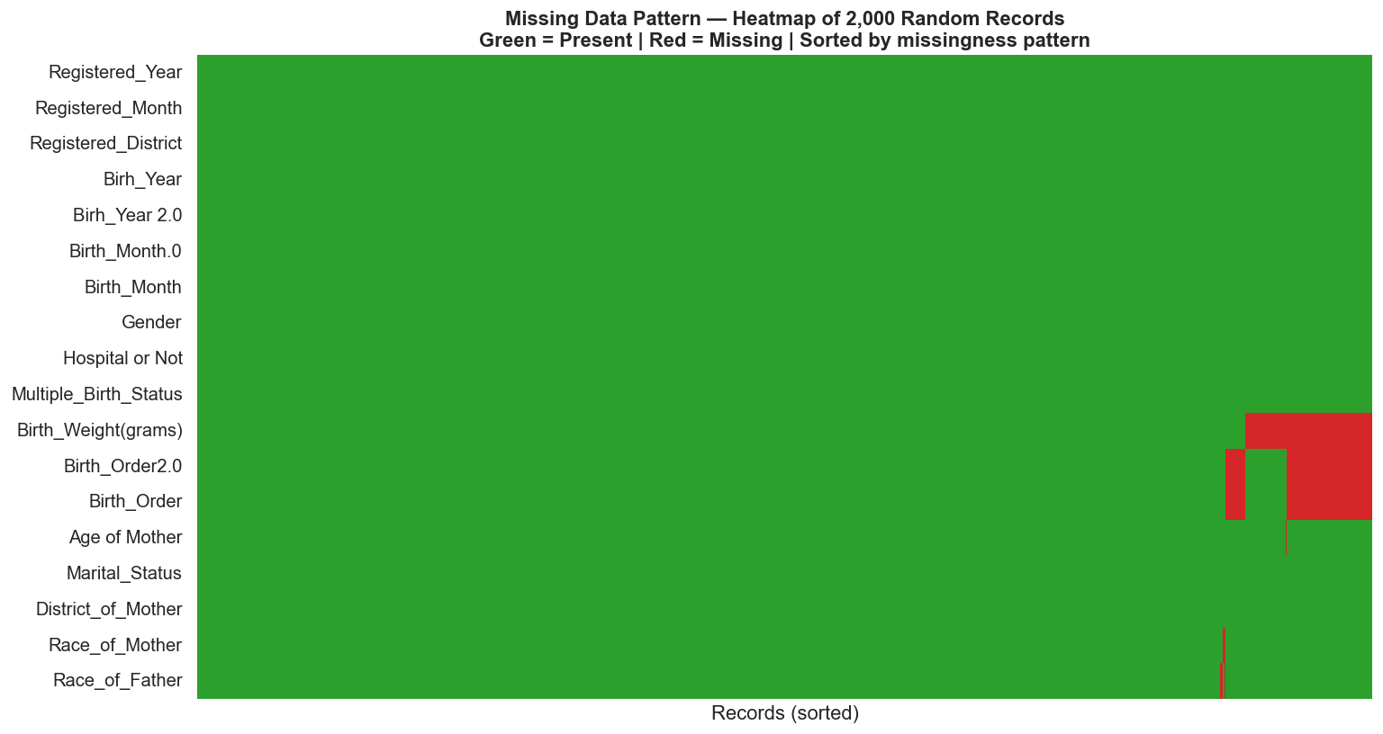
Figure 2. Heatmap of missingness across a random sample of records (green = present, red = missing).
Table 2. Top missingness patterns (1 = missing, 0 = present).
Pattern code | N records | % of dataset | Variables missing
FalseFalseFalseFalseFalseFalseFalseFalseFalseFalseFalseFals… | 261,556 | 86.6906% | COMPLETE — no variables missing
FalseFalseFalseFalseFalseFalseFalseFalseFalseFalseTrueTrueT… | 21,364 | 7.0809% | COMPLETE — no variables missing
FalseFalseFalseFalseFalseFalseFalseFalseFalseFalseTrueFalse… | 11,663 | 3.8656% | COMPLETE — no variables missing
FalseFalseFalseFalseFalseFalseFalseFalseFalseFalseFalseTrue… | 5,523 | 1.8306% | COMPLETE — no variables missing
FalseFalseFalseFalseFalseFalseFalseFalseFalseFalseFalseFals… | 635 | 0.2105% | COMPLETE — no variables missing
FalseFalseFalseFalseFalseFalseFalseFalseFalseFalseFalseFals… | 222 | 0.0736% | COMPLETE — no variables missing
FalseFalseFalseFalseFalseFalseFalseFalseFalseFalseFalseFals… | 171 | 0.0567% | COMPLETE — no variables missing
FalseFalseFalseFalseFalseFalseFalseFalseFalseFalseTrueTrueT… | 162 | 0.0537% | COMPLETE — no variables missing
FalseFalseFalseFalseFalseFalseFalseFalseFalseFalseTrueFalse… | 155 | 0.0514% | COMPLETE — no variables missing
FalseFalseFalseFalseFalseFalseFalseFalseFalseFalseTrueFalse… | 49 | 0.0162% | COMPLETE — no variables missing
FalseFalseFalseFalseFalseFalseFalseFalseFalseFalseTrueTrueT… | 38 | 0.0126% | COMPLETE — no variables missing
FalseFalseFalseFalseFalseFalseFalseFalseFalseFalseFalseTrue… | 23 | 0.0076% | COMPLETE — no variables missing
FalseFalseFalseFalseFalseFalseFalseFalseFalseFalseTrueTrueT… | 21 | 0.0070% | COMPLETE — no variables missing
FalseFalseFalseFalseFalseFalseFalseFalseFalseFalseFalseTrue… | 14 | 0.0046% | COMPLETE — no variables missing
FalseFalseFalseFalseFalseFalseFalseFalseFalseFalseFalseTrue… | 14 | 0.0046% | COMPLETE — no variables missing
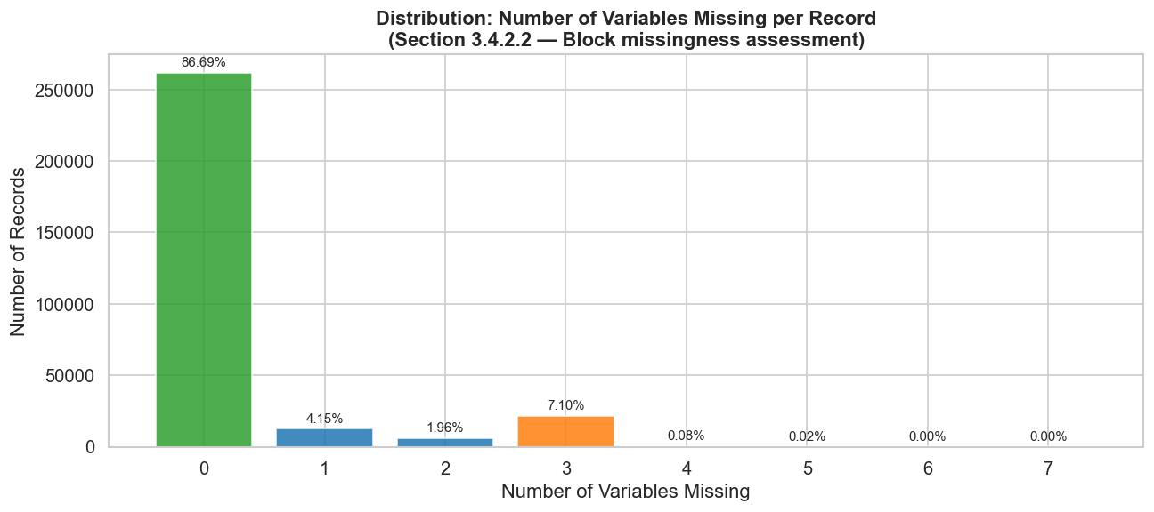
Figure 3. Distribution of records by number of variables missing.

5. Missingness Correlation Matrix
Strong positive correlation between missingness indicators on two variables suggests a shared mechanism — for example, a non-hospital delivery producing missingness on both Birth Weight and Hospital Indicator simultaneously.
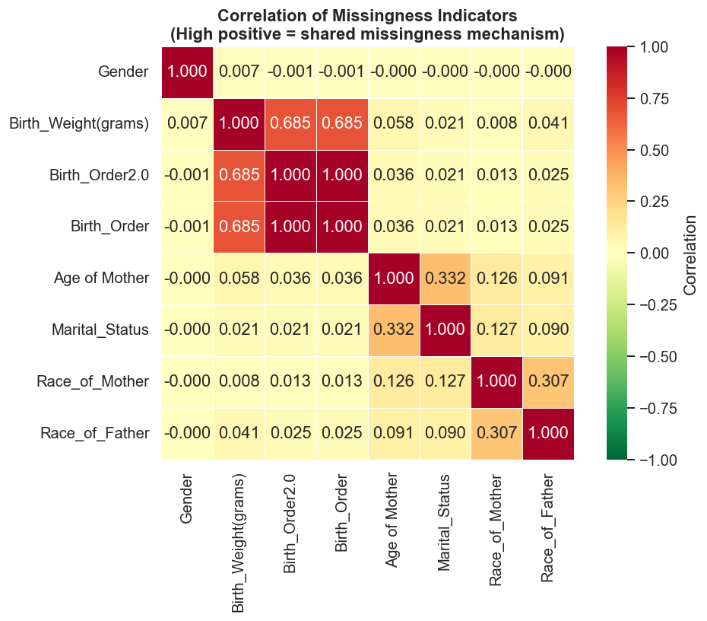
Figure 4. Pearson correlation between missingness indicators.

6. Little's (1988) MCAR Test
Little's test formally tests the null hypothesis that the data are Missing Completely At Random. A non-significant result is consistent with MCAR; a significant result rejects MCAR and implies MAR or MNAR. Note that the test is sensitive to large sample size and may reject MCAR for trivial departures, so results are interpreted alongside pattern visualisations.

7. MAR Mechanism Tests (Section 3.4.2.2)
Each variable with non-zero missingness was tested against every other available predictor. Significant associations support an MAR mechanism: missingness on the variable can be explained by observed values of other variables.
Table 3. MAR mechanism tests — significant associations indicate that missingness depends on observed predictors.
Missing variable | Tested against | Predictor type | Test | Statistic | df | p-value | Significant association
Birth_Weight(grams) | Marital_Status | Categorical | Chi-square | 3654.119 | 1 | < 0.001 | YES — MAR consistent
Birth_Weight(grams) | Race_of_Mother | Categorical | Chi-square | 15897.773 | 5 | < 0.001 | YES — MAR consistent
Birth_Weight(grams) | Gender | Categorical | Chi-square | 7.808 | 1 | 0.0052 | YES — MAR consistent
Birth_Weight(grams) | Hospital or Not | Categorical | Chi-square | 1613.323 | 1 | < 0.001 | YES — MAR consistent
Birth_Weight(grams) | Multiple_Birth_Status | Categorical | Chi-square | 57.681 | 4 | < 0.001 | YES — MAR consistent
Birth_Weight(grams) | Birth_Order | Categorical | Chi-square | 2838.663 | 8 | < 0.001 | YES — MAR consistent
Birth_Weight(grams) | Age of Mother | Continuous | Mann-Whitney U | 4261400693.0 | — | < 0.001 | YES — MAR consistent
Birth_Order2.0 | Marital_Status | Categorical | Chi-square | 1313.511 | 1 | < 0.001 | YES — MAR consistent
Birth_Order2.0 | Race_of_Mother | Categorical | Chi-square | 32524.74 | 5 | < 0.001 | YES — MAR consistent
Birth_Order2.0 | Gender | Categorical | Chi-square | 3.609 | 1 | 0.0575 | No
Birth_Order2.0 | Hospital or Not | Categorical | Chi-square | 601.292 | 1 | < 0.001 | YES — MAR consistent
Birth_Order2.0 | Multiple_Birth_Status | Categorical | Chi-square | 126.351 | 4 | < 0.001 | YES — MAR consistent
Birth_Order2.0 | Age of Mother | Continuous | Mann-Whitney U | 3755946193.0 | — | 0.0162 | YES — MAR consistent
Birth_Order | Marital_Status | Categorical | Chi-square | 1313.511 | 1 | < 0.001 | YES — MAR consistent
Birth_Order | Race_of_Mother | Categorical | Chi-square | 32524.74 | 5 | < 0.001 | YES — MAR consistent
Birth_Order | Gender | Categorical | Chi-square | 3.609 | 1 | 0.0575 | No
Birth_Order | Hospital or Not | Categorical | Chi-square | 601.292 | 1 | < 0.001 | YES — MAR consistent
Birth_Order | Multiple_Birth_Status | Categorical | Chi-square | 126.351 | 4 | < 0.001 | YES — MAR consistent
Birth_Order | Age of Mother | Continuous | Mann-Whitney U | 3755946193.0 | — | 0.0162 | YES — MAR consistent
Race_of_Father | Marital_Status | Categorical | Chi-square | 16380.757 | 1 | < 0.001 | YES — MAR consistent
Race_of_Father | Race_of_Mother | Categorical | Chi-square | 183.575 | 5 | < 0.001 | YES — MAR consistent
Race_of_Father | Gender | Categorical | Chi-square | 5.31 | 1 | 0.0212 | YES — MAR consistent
Race_of_Father | Hospital or Not | Categorical | Chi-square | 240.984 | 1 | < 0.001 | YES — MAR consistent
Race_of_Father | Multiple_Birth_Status | Categorical | Chi-square | 3.212 | 4 | 0.5230 | No
Race_of_Father | Birth_Order | Categorical | Chi-square | 186.902 | 8 | < 0.001 | YES — MAR consistent
Race_of_Father | Age of Mother | Continuous | Mann-Whitney U | 157972994.5 | — | < 0.001 | YES — MAR consistent
Race_of_Mother | Marital_Status | Categorical | Chi-square | 65.116 | 1 | < 0.001 | YES — MAR consistent
Race_of_Mother | Gender | Categorical | Chi-square | 1.506 | 1 | 0.2198 | No
Race_of_Mother | Hospital or Not | Categorical | Chi-square | 3.604 | 1 | 0.0576 | No
Race_of_Mother | Multiple_Birth_Status | Categorical | Chi-square | 32.351 | 4 | < 0.001 | YES — MAR consistent
Race_of_Mother | Birth_Order | Categorical | Chi-square | 3.763 | 8 | 0.8779 | No
Race_of_Mother | Age of Mother | Continuous | Mann-Whitney U | 81036189.0 | — | < 0.001 | YES — MAR consistent
Age of Mother | Marital_Status | Categorical | Chi-square | 1452.657 | 1 | < 0.001 | YES — MAR consistent
Age of Mother | Race_of_Mother | Categorical | Chi-square | 36.109 | 5 | < 0.001 | YES — MAR consistent
Age of Mother | Gender | Categorical | Chi-square | 0.152 | 1 | 0.6966 | No
Age of Mother | Hospital or Not | Categorical | Chi-square | 261.805 | 1 | < 0.001 | YES — MAR consistent
Age of Mother | Multiple_Birth_Status | Categorical | Chi-square | 1.557 | 4 | 0.8165 | No
Age of Mother | Birth_Order | Categorical | Chi-square | 64.255 | 8 | < 0.001 | YES — MAR consistent
Marital_Status | Race_of_Mother | Categorical | Chi-square | 3.825 | 5 | 0.5748 | No
Marital_Status | Gender | Categorical | Chi-square | 0.346 | 1 | 0.5566 | No
Marital_Status | Hospital or Not | Categorical | Chi-square | 4.841 | 1 | 0.0278 | YES — MAR consistent
Marital_Status | Multiple_Birth_Status | Categorical | Chi-square | 0.172 | 4 | 0.9965 | No
Marital_Status | Birth_Order | Categorical | Chi-square | 2.774 | 8 | 0.9477 | No
Gender | Marital_Status | Categorical | Chi-square | 0.0 | 1 | 1.0000 | No
Gender | Race_of_Mother | Categorical | Chi-square | 0.891 | 5 | 0.9709 | No
Gender | Hospital or Not | Categorical | Chi-square | 0.0 | 1 | 1.0000 | No
Gender | Multiple_Birth_Status | Categorical | Chi-square | 0.02 | 4 | 0.9999 | No
Gender | Birth_Order | Categorical | Chi-square | 3.526 | 8 | 0.8971 | No
Gender | Age of Mother | Continuous | Mann-Whitney U | 380879.5 | — | 0.5188 | No

8. Birth Weight × Delivery Setting (Critical MAR Test)
This is the single most important MAR test for the study. Birth weight is expected to have higher missingness among non-hospital deliveries because accurate measurement requires clinical weighing equipment unavailable in many home delivery settings. Confirmation of this pattern supports the validity of listwise deletion when delivery setting is included in the regression models.

Test statistics:
- χ² = 15.220, df = 8
- p-value = 0.0550

Conclusion: No significant association detected. The MAR mechanism via delivery setting is not supported in this dataset; sensitivity analysis using multiple imputation may be warranted (Sterne et al., 2009).
[Figure not found: fig5_bw_missingness_by_setting.png]

9. Listwise Deletion Results (Section 3.4.2.3)
Listwise deletion was applied to the analytical variable set; records missing on any predictor or outcome were removed.

10. Sensitivity Analysis: Retained vs Dropped (Section 3.4.2.4)
Characteristics of retained records were compared with those dropped by listwise deletion to verify that the analytical sample remains representative. Significant differences are expected in large datasets and do not necessarily invalidate listwise deletion — the magnitude of difference (descriptive statistics) is what matters substantively.
Table 5. Comparison of retained vs dropped records.
Variable | Type | Retained (mean) | Dropped (mean) | Retained (median) | Dropped (median) | Test | p-value | Different?
Age of Mother | Continuous | 29.12 | 29.25 | 29.0 | 29.0 | Mann-Whitney U | 0.0066 | YES
Marital_Status | Categorical | mode: Married | mode: Married | — | — | Chi-square | < 0.001 | YES
Race_of_Mother | Categorical | mode: Sinhalese | mode: Srilankan Tamil | — | — | Chi-square | < 0.001 | YES
Gender | Categorical | mode: Male | mode: Male | — | — | Chi-square | 0.0464 | YES
Hospital or Not | Categorical | mode: Hospital | mode: Hospital | — | — | Chi-square | < 0.001 | YES
Multiple_Birth_Status | Categorical | mode: Singleton | mode: Singleton | — | — | Chi-square | < 0.001 | YES
Birth_Order | Categorical | mode: First | mode: First | — | — | Chi-square | 0.0550 | No
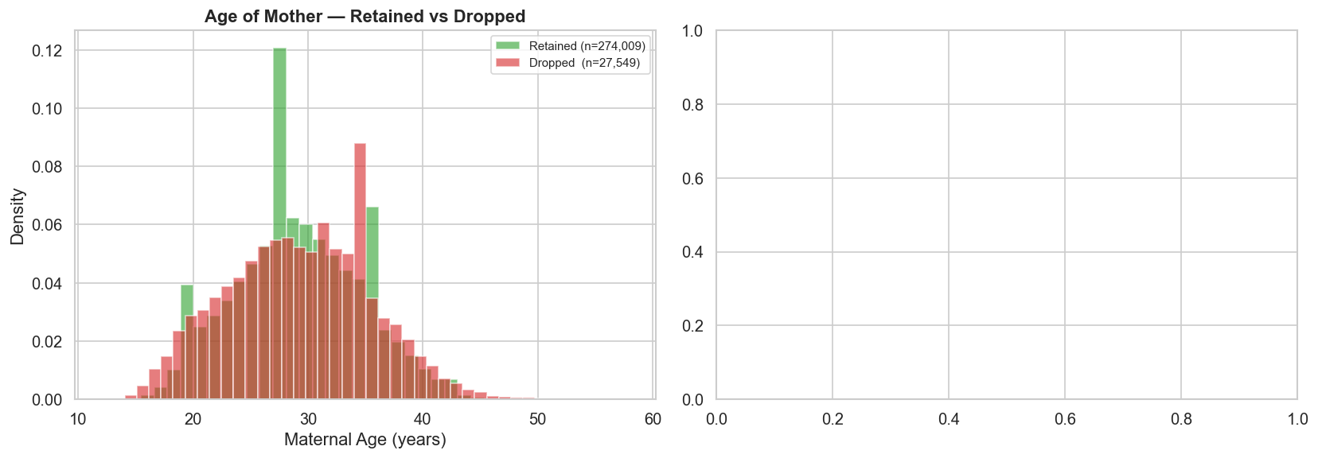
Figure 6. Distribution comparison: retained vs dropped records (continuous variables).

11. Summary Dashboard
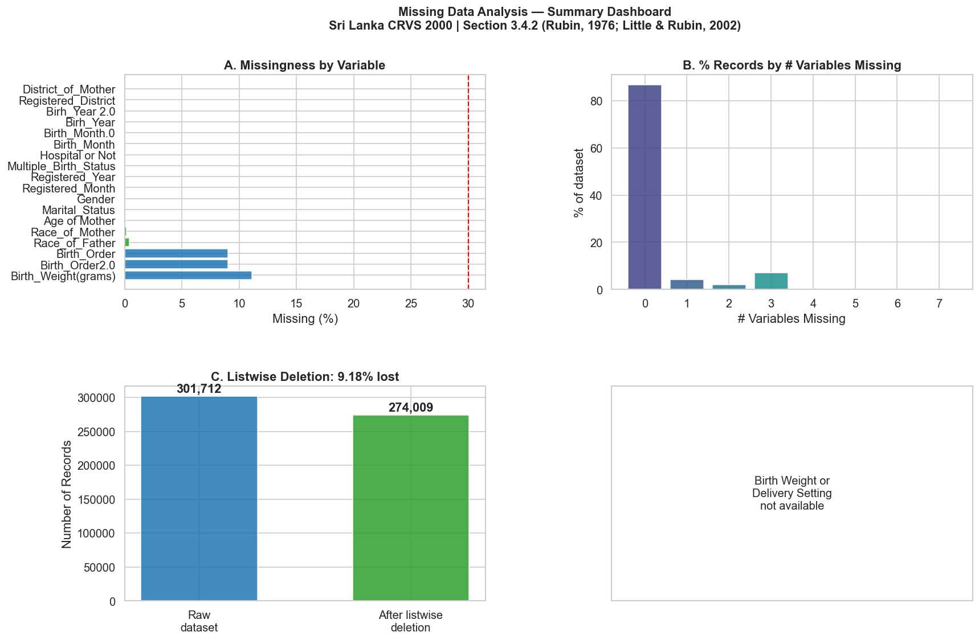
Figure 7. Summary dashboard combining missingness by variable, records by number of missing variables, listwise deletion waterfall, and the BW × delivery-setting test.

12. Conclusions
- The raw dataset contained 301,712 records. Listwise deletion retained 274,009 (90.82%) for analysis.
- Variables with low missingness (< 5%): Race_of_Father, Race_of_Mother, Age of Mother, Marital_Status, Gender, Registered_Month, Registered_Year, Multiple_Birth_Status, Hospital or Not, Birth_Month, Birth_Month.0, Birh_Year, Birh_Year 2.0, Registered_District, District_of_Mother.
- The cleaned analytical dataset (crvs_2000_complete_cases.csv) is ready for outlier analysis (Section 3.4.1), chi-square tests of association (Section 3.5.2), and regression modelling — binary, ordinal, and multinomial (Section 3.5.3).

13. References
Agresti, A. (2018). Statistical methods for the social sciences (5th ed.). Pearson Education.
Department of Census and Statistics Sri Lanka. (2002). Sri Lanka Demographic and Health Survey 2000.
Hosmer, D. W., Lemeshow, S., & Sturdivant, R. X. (2013). Applied logistic regression (3rd ed.). Wiley. https://doi.org/10.1002/9781118548387
Little, R. J. A. (1988). A test of missing completely at random for multivariate data with missing values. Journal of the American Statistical Association, 83(404), 1198–1202. https://doi.org/10.1080/01621459.1988.10478722
Little, R. J. A., & Rubin, D. B. (2002). Statistical analysis with missing data (2nd ed.). Wiley. https://doi.org/10.1002/9781119013563
Ministry of Health Sri Lanka. (2000). Annual Health Bulletin 2000. Ministry of Health.
Rubin, D. B. (1976). Inference and missing data. Biometrika, 63(3), 581–592. https://doi.org/10.1093/biomet/63.3.581
Rutstein, S. O., & Rojas, G. (2006). Guide to DHS statistics (DHS-IV). ORC Macro.
Sterne, J. A. C., White, I. R., Carlin, J. B., Spratt, M., Royston, P., Kenward, M. G., Wood, A. M., & Carpenter, J. R. (2009). Multiple imputation for missing data in epidemiological and clinical research: Potential and pitfalls. BMJ, 338, b2393. https://doi.org/10.1136/bmj.b2393
United Nations, Department of Economic and Social Affairs, Population Division. (2014). Principles and recommendations for a vital statistics system: Revision 3 (Statistical Papers, Series M, No. 19/Rev.3). United Nations.
World Health Organization. (2014). Global nutrition targets 2025: Low birth weight policy brief (WHO/NMH/NHD/14.5). WHO.

